Can We Predict Hotel Booking Cancellations Before They Happen?
Analyzing booking behavior to help hotels reduce revenue loss
ANALYZING BOOKING TRENDS IN THE HOSPITALITY INDUSTRY
A predictive model to determine the booking status of a customer
Hotel Haven is a luxury hotel chain with multiple locations. The hotel offers a wide range of services, including various types of rooms, meal plans, and parking options.
Hotel Haven has been facing challenges in predicting customer cancellations, which impacts their ability to manage resources effectively. The hotel wants to better understand their booking patterns and create strategies that could improve customer retention and reduce cancellations.
Problem Statement
hotel struggles with high cancellation rates, leading to lost revenue and inefficient resource allocation. The existing system does not provide sufficient insights into why customers cancel their bookings. The hotel management seeks to predict cancellations based on booking data to improve operational efficiency and customer retention.
Spectific Objectives
-- Clean the date and prepared for Analysis
-- Analyzing booking data to understand patterns, trends and reasons why customers cancel their bookings.
-- By examining variables like lead time, room type, market segment, and price, the project allows the identification of specific factors that influence customers' decisions to either cancel or keep their bookings.
-- Feature Engineering to add insights to the data
-- Build Predictive model to predict cancellation behaviour of the customers
-- Evaluate the model to assess it performance
-- Model Fine Tune
-- Deployment of model on streamlit app to enable user interaction

WorkFlow Overview
-- Data Cleaning --> Data Explorations --> Comprehensive Data Analysis -->Feature Engineering --> Model Development --> Model Evaluation --> Fine Tuning
Booking status statistics is showing that over 67% (24396) of Hotel Haven have not yet canceled their booking tickets. With over 33% (11889) cancellation status
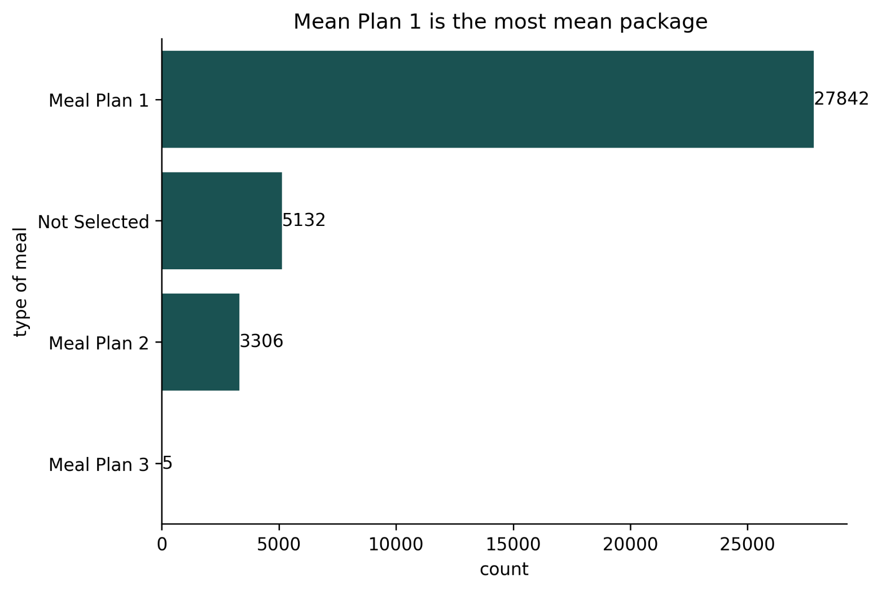
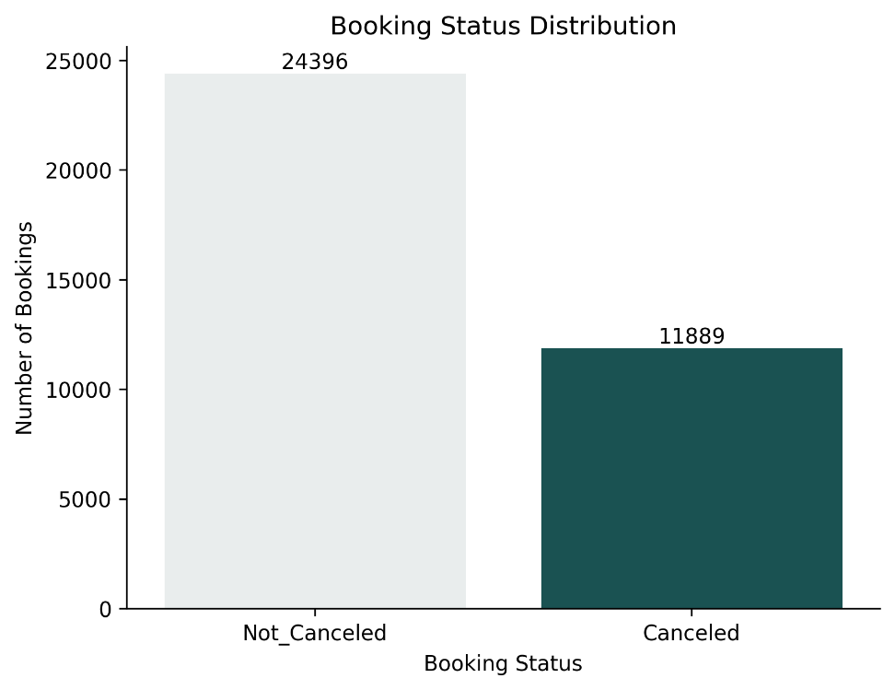
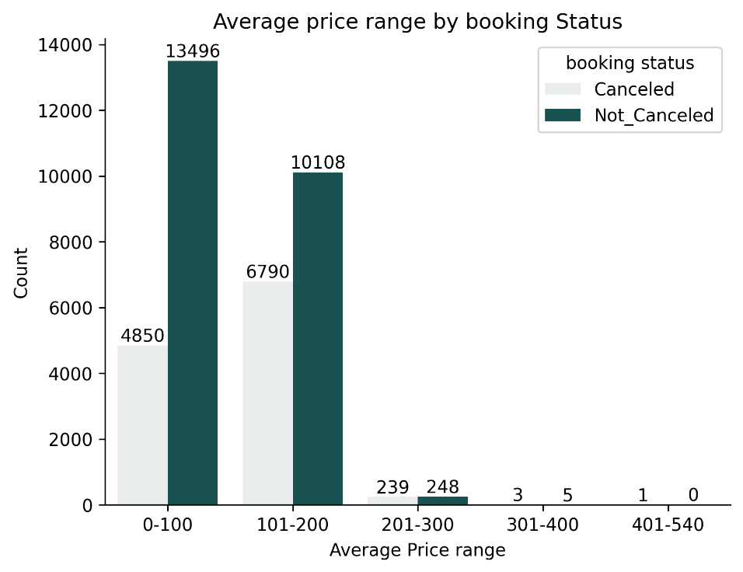
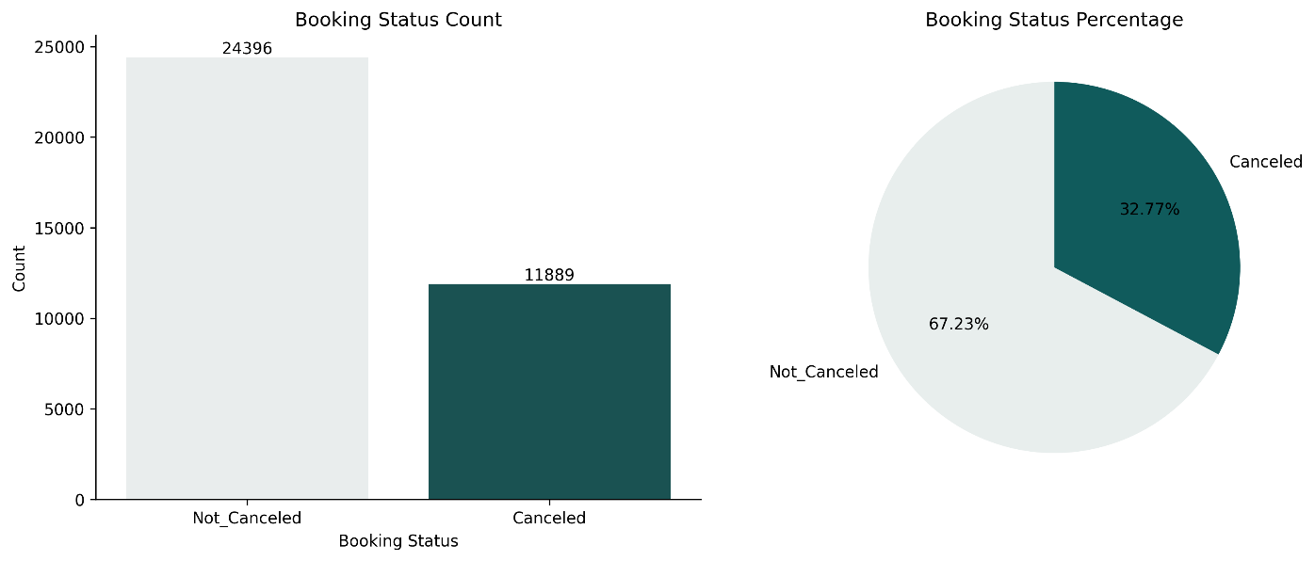
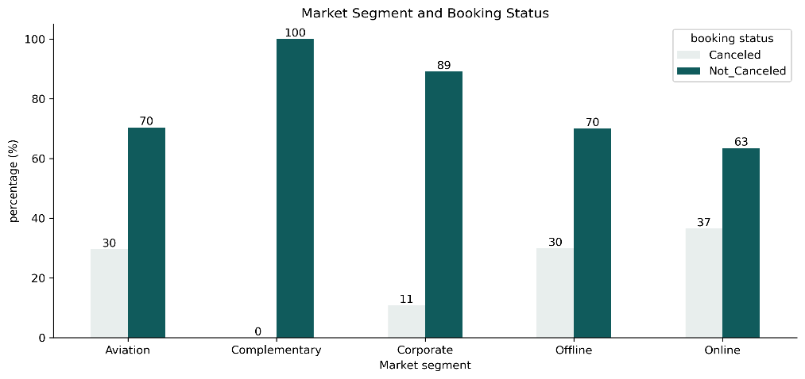
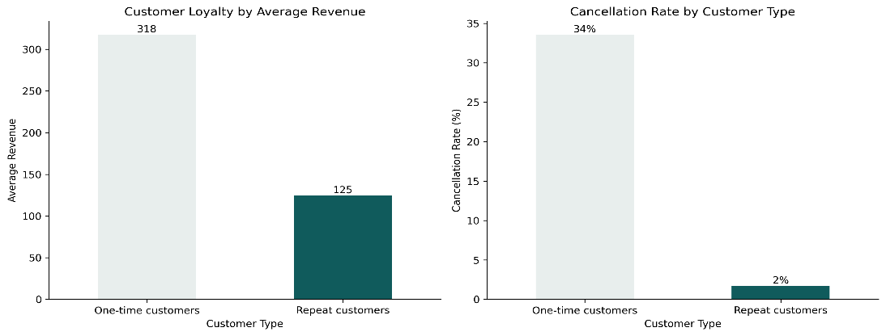
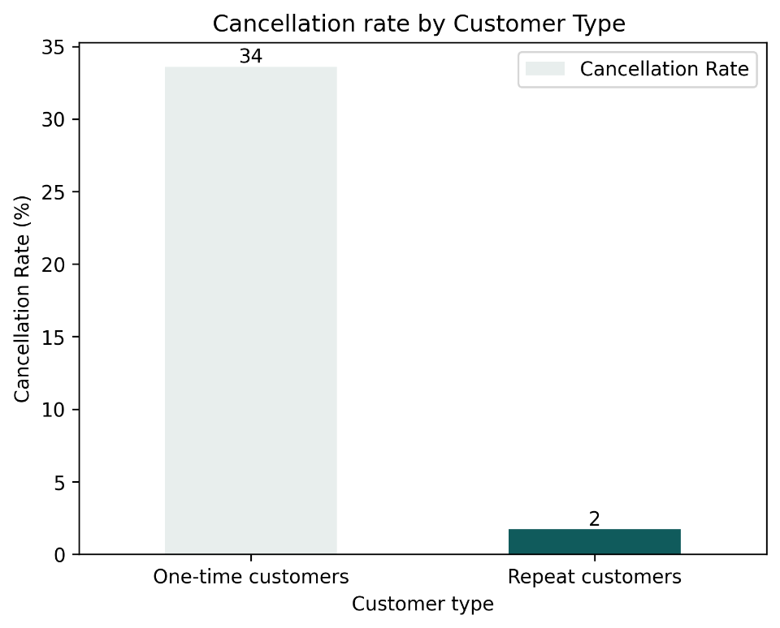
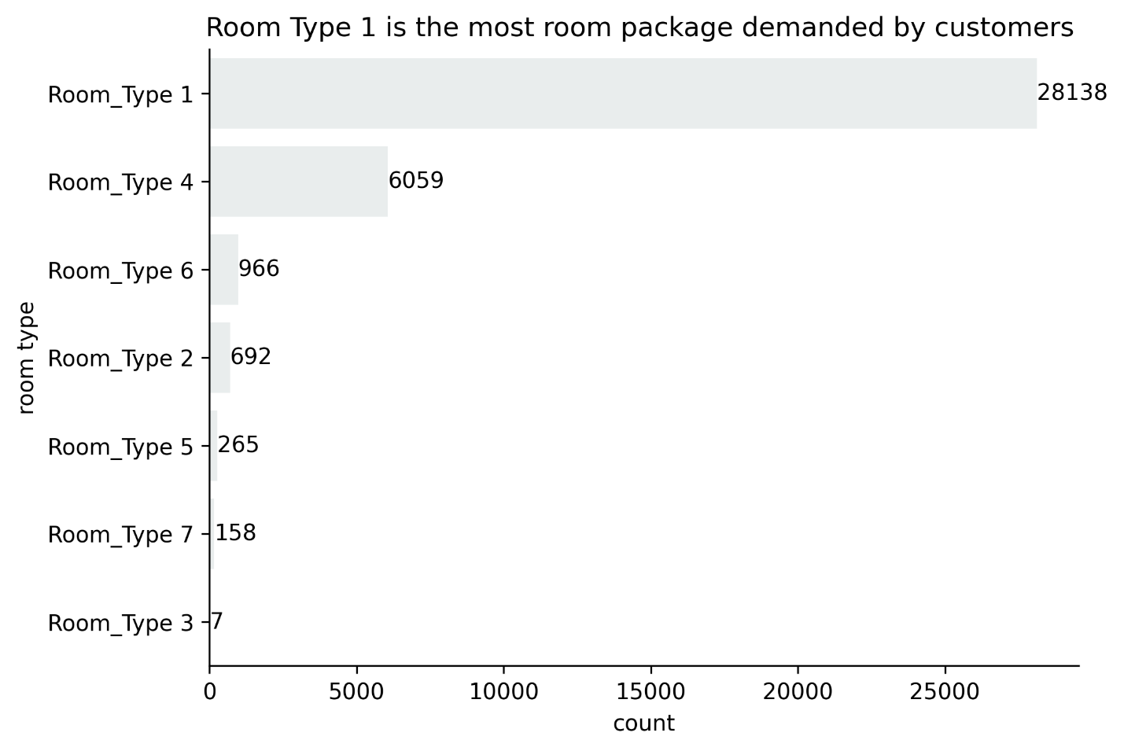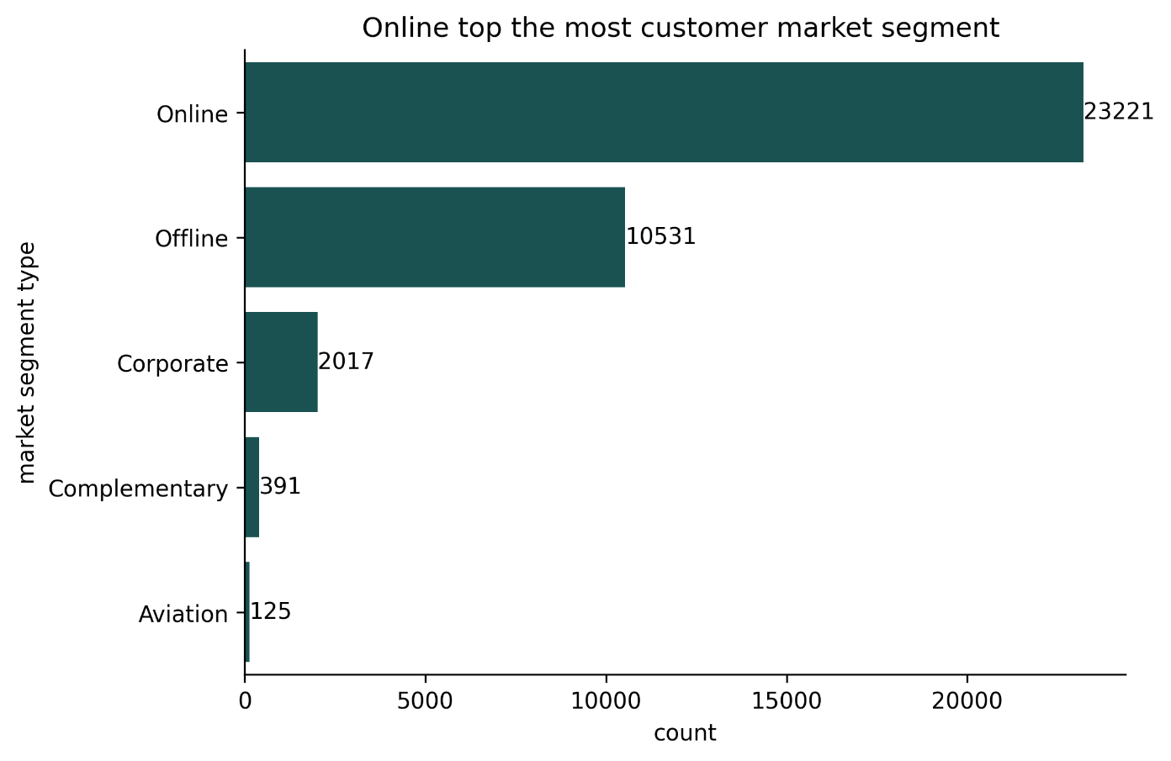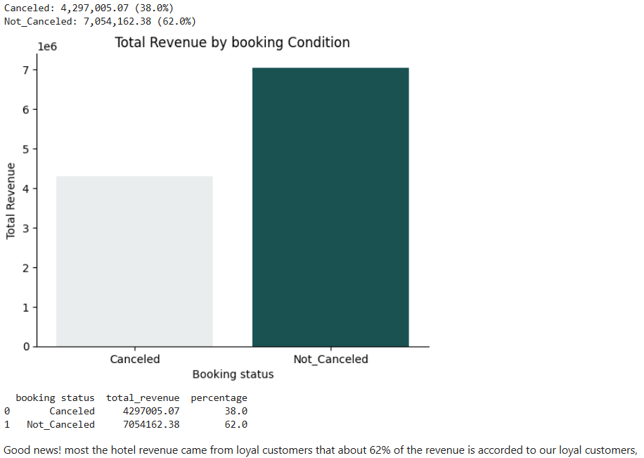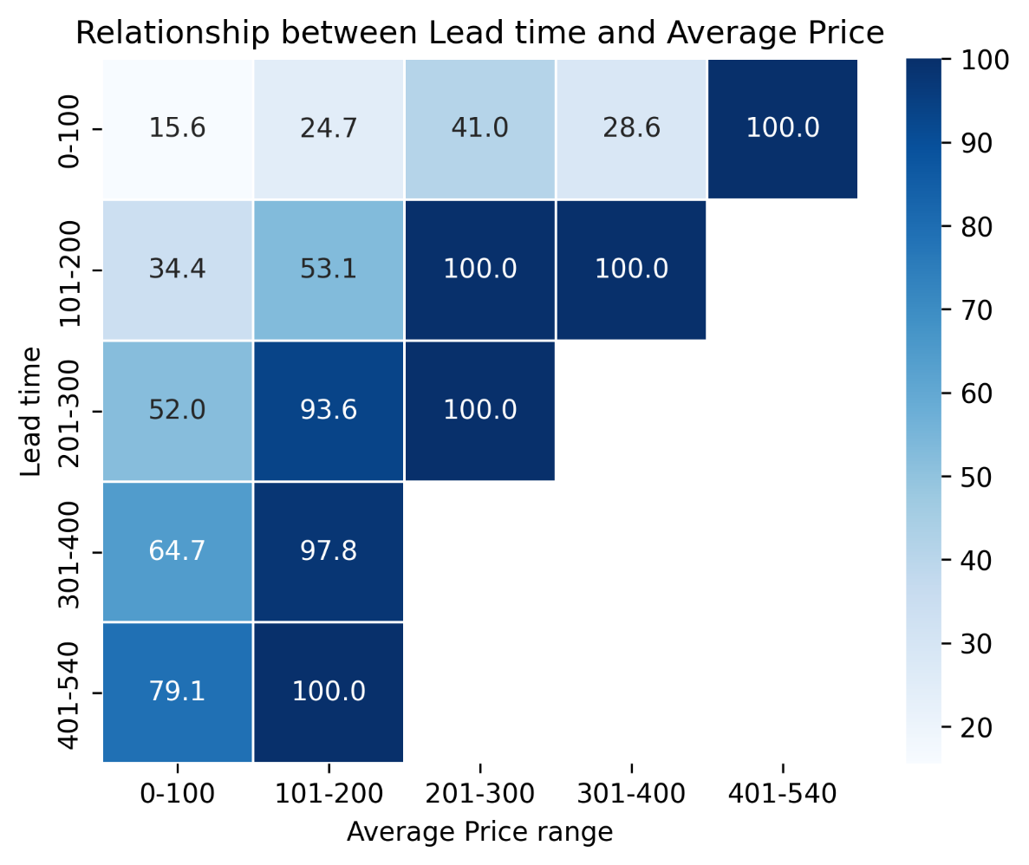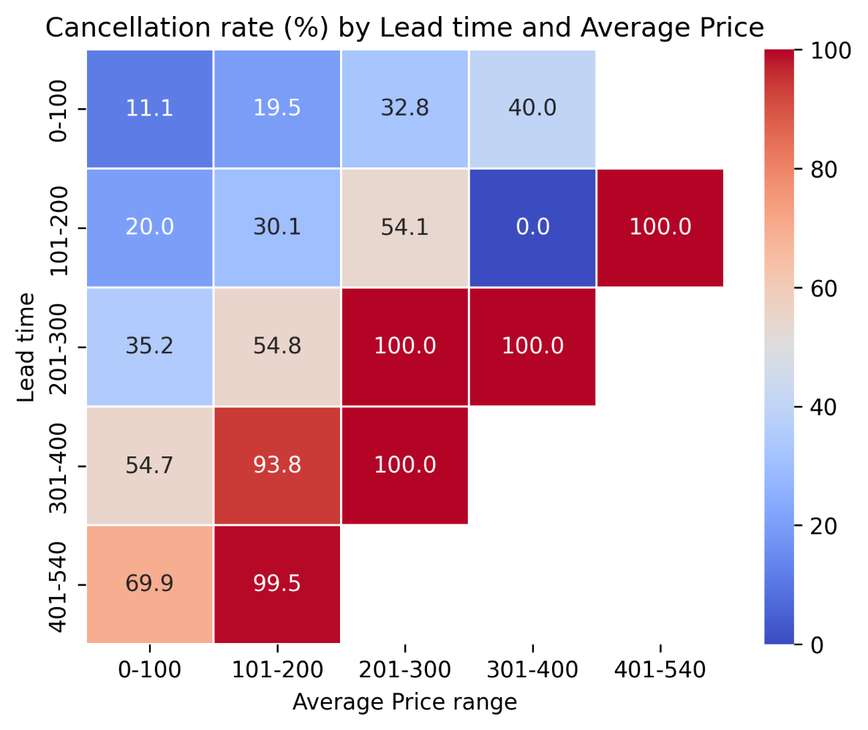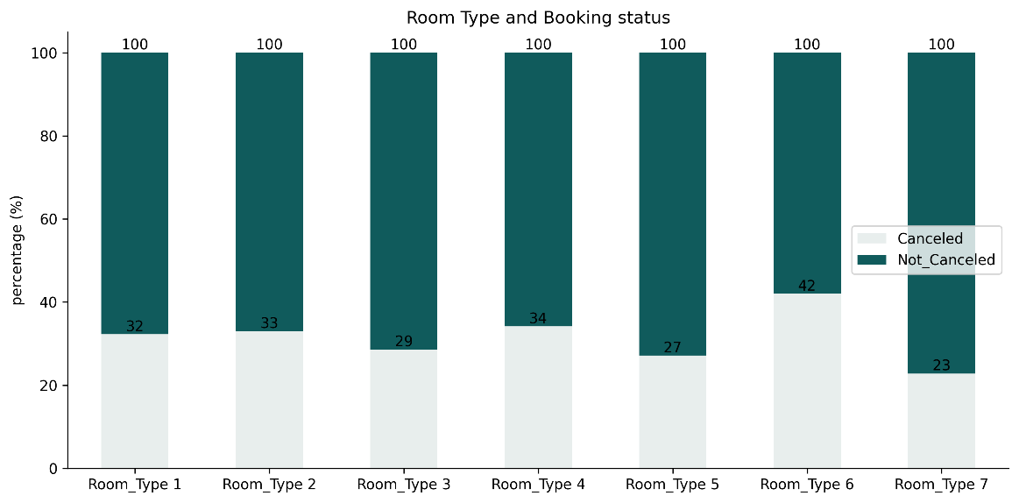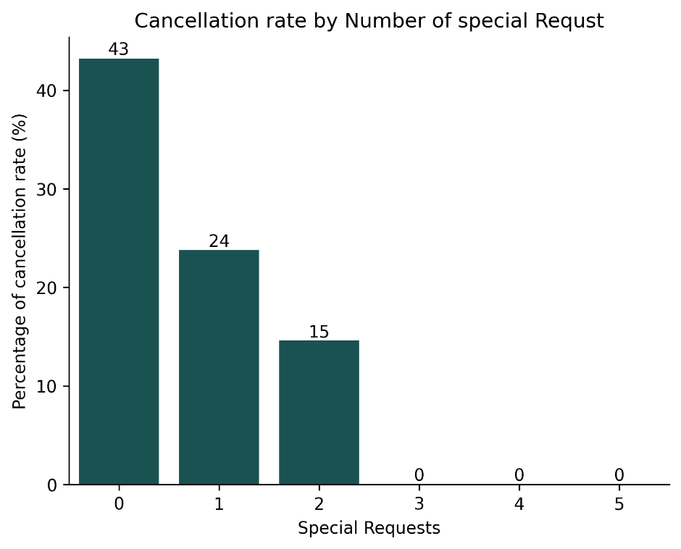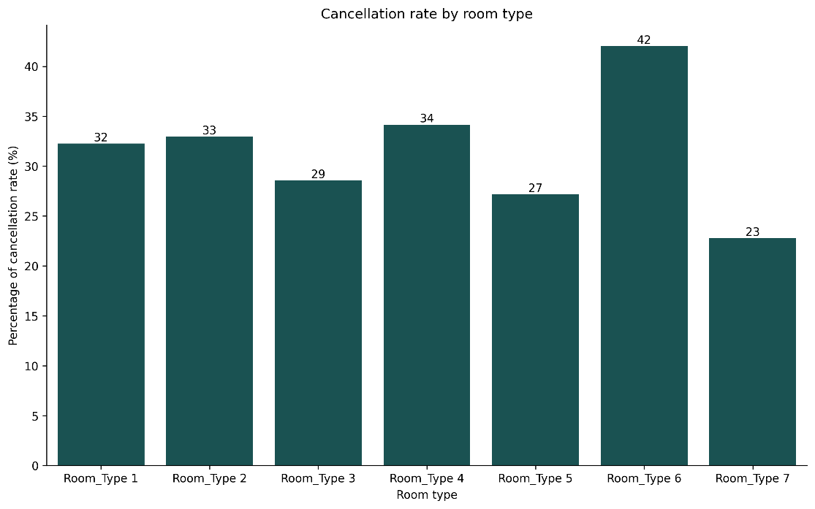
Good news! most the hotel revenue came from loyal customers that about 62% of the revenue is accorded to our loyal customers,
A look at the average price by booking status shows that the average price range between 101 and 200 USD recorded the highest cancellation behavior. Followed by an average price range of 0 and 100 USD. While high-premium customers with an average price of 301 to 540 USD record very little cancellation status. This tells us something about the Premium customer. The highest cancellation status was recorded between our normal customers (average price of 101 to 200 USD) and our medium customers (average price of 101 to 200 USD)
Booking status statistics is showing that over 67% (24396) of Hotel Haven have not yet canceled their booking tickets. With over 33% (11889) cancellation status
We decided to box the average and lead time to be able to understand the cancellation behavior of our customers.
From the analysis it very clear that highest cancellation risk was recorded by high lead time(Time between the reservation and check-in date) across
all average price ranges. This suggests that lead time is the major driver of Hotel Haven cancellation risk.

I decided to try different lead time categorization to see if lead time is still the major cause of canceallation rate...
It still very clear and obvious that lead time play a very significant role in cancellation behaviour of the customers.This means the more reservation time the likely that the customers will change their mind and cancel their booking tickets. From the chart is very noticed that lead time drives the cancellation rate across all average price categories, showing it impact or influence.
No clear/consistent pattern of cancellation rates across room types, with slight variations suggesting room type alone is not a strong predictor of cancellation
Room Type 6 has highest cancellation rate (42%), slight higher, making it Hotel Haven's most at-risk room inventory, Room Type 7 is the most reliable with the lowest cancellation rate (23%)
The absence of descriptive information about each room type limits our ability to explain why certain room types experience higher cancellation rates than others

The more a customers is a special time customers the less likely the customers will cancel their subcription. Special requsts simply entails the Number of special requests made by the customer. Less special requsts customer more likely to cancel their booking tickets and vice versa.

Online bookings have the highest cancellation rate (30%), making them Hotel Haven's biggest cancellation risk. Their seamless booking and cancellation process directly contributes to revenue loss and inefficient resource allocation
With only 11% cancellation rate, corporate guests demonstrate strong booking commitment, representing a stable and predictable revenue stream and efficient resource planning segment
3. Complementary bookings have a 0% cancellation rate, strategic bookings provided at no charge to partners, loyalty members, or media, guests have no reason to cancel. While they generate no direct revenue, they can serve as a basis for revenue generation via verbal referrals, and positive reviews for Hotel Haven

What can you see, one time customers accounted for the largest portion of total revenue (average) but are the first to cancel their booking
Obviously, cancellation rate is higher with our one time customers over 34%
Obviously, cancellation rate is higher with our one time customers over 34%
Room type 6 is the room type with the highest cancellation risk of 42% followed closely is room type 4 with 34% cancellation rate. The lowest cancellation room type is Room Type 7 with cancellation risk of 23%

